26.14 Editors - Properties Editor - Texture Properties Tab
Detailed table of content 2
25.14 Editors - Properties Editor - Texture Tab 7
Brush drop down box 7
Texture property 7
New Texture 8
Remove Texture 8
Type 8
Preview panel 8
Blend panel 8
Clouds panel 9
Noise Basis 9
Type 9
Color 9
Size 9
Depth 9
Nabla 9
Distorted Noise panel 10
Noise Basis 10
Distortion 10
Amount 10
Size 10
Nabla 10
Image panel - Settings Subpanel 10
Image Property 11
Source 11
Image panel - Alpha Subpanel 15
Calculate 15
Invert 15
Image panel - Mapping Subpanel 16
Flip Axes 16
Extension 16
Crop Sub tab 16
Image panel - Sampling Subpanel 17
Interpolation 17
MIP Map 17
Fiter Type 17
Minimum Size 18
Magic panel 18
Depth 18
Turbulence 18
Marble panel 18
Noise Basis 18
Pattern 18
Second basis 18
Type 19
Size 19
Depth 19
Turbulence 19
Nabla 19
Musgrave panel 19
Noise Basis 19
Type 19
Size 19
Nabla 20
Dimension 20
Lacunarity 20
Octaves 20
Intensity 20
Offset 20
Gain 20
Stucci panel 20
Noise Basis 21
Pattern 21
Type 21
Size 21
Turbulence 21
Voronoi panel 21
Distance Metric 21
Coloring 22
Feature Weights subpanel 22
Wood panel 22
Noise Basis 22
Pattern 22
Second basis 22
Type 22
Turbulence 23
Nabla 23
Colors Panel 23
Clamp 23
Multiply R G B 23
Brightness 23
Contrast 23
Saturation 23
Color ramp subpanel 23
Custom Properties Panel 25
Add 25
Edit 25
Remove 25

Detailed table of content

Detailed table of content
Detailed table of content 2
25.14 Editors - Properties Editor - Texture Tab 7
Brush drop down box 7
Texture property 7
Texture browser 7
Edit Box 7
Number of users 7
Fake User 7
New Texture 8
Remove Texture 8
Type 8
Preview panel 8
Blend panel 8
Progression 8
Orientation 9
Clouds panel 9
Noise Basis 9
Type 9
Color 9
Grayscale 9
Color 9
Size 9
Depth 9
Nabla 9
Distorted Noise panel 10
Noise Basis 10
Distortion 10
Amount 10
Size 10
Nabla 10
Image panel - Settings Subpanel 10
Image Property 11
Image Browser 11
New / Open 11
Image Edit Box 11
Fake User 11
Open Image 11
Remove 11
Source 11
Source Type Generated 11
X / Y 11
Float Buffer 11
Generated Type Blank 12
Color 12
Generated Type UV Grid 12
Generated Type Color Grid 12
Color Space 12
View as Render 12
Source Type Movie + Image Sequence 13
Path edit box 13
Pack 13
Path edit box 13
Open 13
Refresh 13
Info string 13
Frames 13
Match Movie Length 13
Start 13
Offset 13
Cyclic 13
Auto Refresh 14
Deinterlace 14
Color Space 14
Alpha 14
View as Render 14
Source Type Single Image 14
Path edit box 14
Pack 14
Path edit box 14
Open 14
Refresh 14
Info string 15
Color Space 15
Alpha 15
View as Render 15
Source Type Udim 15
Image panel - Alpha Subpanel 15
Calculate 15
Invert 15
Image panel - Mapping Subpanel 16
Flip Axes 16
Extension 16
Extend 16
Clip 16
Clip Cube 16
Repeat 16
Repeat X / Y 16
Mirror X / Y 16
Checker 16
Distance 16
Tiles Even / Odd 16
Crop Sub tab 16
Crop Minimum X / Y + Crop Maximum X / Y 16
Image panel - Sampling Subpanel 17
Interpolation 17
MIP Map 17
Gaussian Filter 17
Fiter Type 17
Type Box 17
Size 17
Type EWA 17
Eccentricity 17
Size 17
Type FELINE 17
Light Probes 17
Size 17
Type Area 17
Eccentricity 17
Size 18
Minimum Size 18
Magic panel 18
Depth 18
Turbulence 18
Marble panel 18
Noise Basis 18
Pattern 18
Second basis 18
Type 19
Size 19
Depth 19
Turbulence 19
Nabla 19
Musgrave panel 19
Noise Basis 19
Type 19
Size 19
Nabla 20
Dimension 20
Lacunarity 20
Octaves 20
Intensity 20
Offset 20
Gain 20
Stucci panel 20
Noise Basis 21
Pattern 21
Type 21
Size 21
Turbulence 21
Voronoi panel 21
Distance Metric 21
Exponent 21
Coloring 22
Feature Weights subpanel 22
Wood panel 22
Noise Basis 22
Pattern 22
Second basis 22
Type 22
Turbulence 23
Nabla 23
Colors Panel 23
Clamp 23
Multiply R G B 23
Brightness 23
Contrast 23
Saturation 23
Color ramp subpanel 23
+ 23
- 23
Tools menu 24
Flip Color Ramp 24
Distribute Stops from Left 24
Distribute Stops Evenly 24
Eyedropper (pipette icon) E 24
Reset Color Ramp 24
Color Mode 24
RGB 24
HSV/HSL 24
Interpolation 24
Ease 24
Cardinal 24
Linear 24
B-Spline 24
Constant 24
Color Ramp 25
Active Color Stop elements 25
Choose active color stop 25
Pos 25
Color 25
Custom Properties Panel 25
Add 25
Edit 25
Remove 25

25.14 Editors - Properties Editor - Texture Tab

In this panel you can create or load textures for the brushes in the image painting modes.
Note that with the Workbench renderer you have less options.

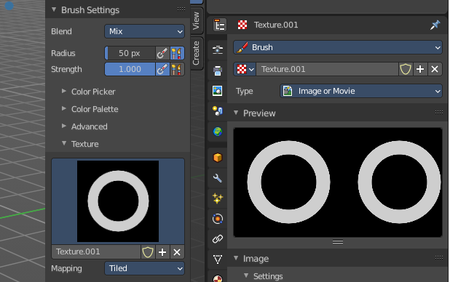
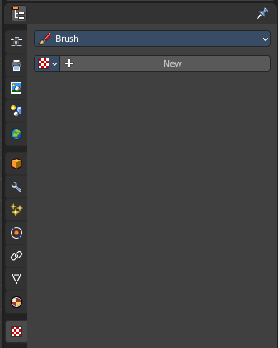

Brush drop down box
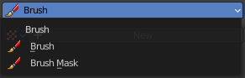
What kind of brush texture you want to create. A brush texture, or a brush mask texture. Brush textures appears in the texture panel of the brush settings. Brush mask textures appears in the texture mask panel of the brush settings.

Texture property

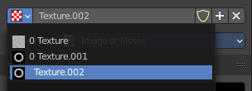
Texture browser
A texture browser with the available textures.

Edit Box
The name of the currently active palette. You can also rename the palette here. A click into the edit box makes the name editable.

Number of users
See how many users the palette currently has.

Fake User
Fake User sets the element to have a fake user. Data without a user is normally not saved. But sometimes you want to force the data to be kept even when the data block has no user.

New Texture
Add a new texture

Remove Texture
Removes the texture as the active texture. Note that the texture is still in the list.

Type
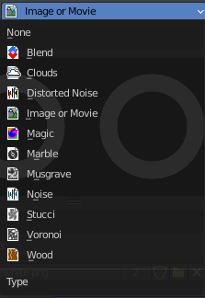
The image type to use. Image or Movie uses pixel based material that you have to load externally. The rest are procedural computer generated textures. Some of them are based at different noise algorithms.
Each texture type has its own settings which will be described below.

Preview panel
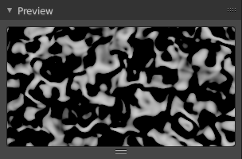
A preview window for the texture.

Blend panel
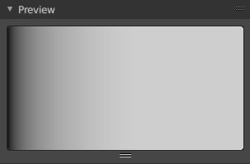
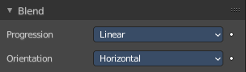
Image Type Blend.

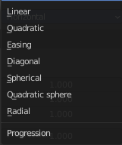
Progression
The style of the color blending.

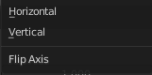
Orientation
The direction. Horizontal or vertical.

Clouds panel

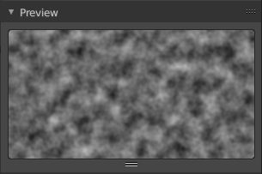
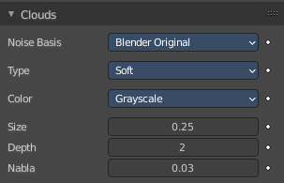
Image type clouds

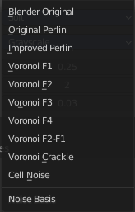
Noise Basis
What noise method to use.

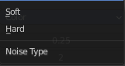
Type
Smooth transitions or sharp transitions. Changes contrast and sharpness.

Color

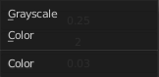
Grayscale
Grayscale based noise. The value returned is greyscale 8 bit.

Color
The noise gives an RGB value. The value returned is rgb 24 bit.

Size
The dimension of the Noise table.

Depth
The depth of the Clouds calculation. A higher number results in a long calculation time, but also in finer details.

Nabla
Size of derivate offset used for calculating normal.
In order to calculate a normal, you usually use three samples in texture space. Typically that's the current sample location, and two other positions in texture U and V directions. This "nabla" value defines how far away these positions are.

Distorted Noise panel

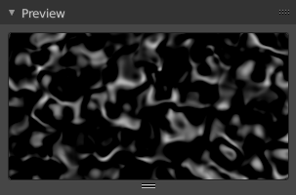
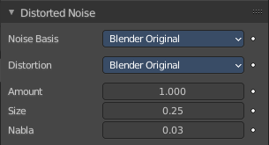
Image type Distorted Noise

Noise Basis
What noise method to use.

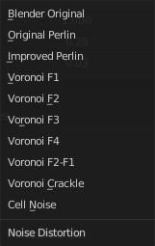
Distortion
What noise method to use for the distortion.

Amount
The amount of distortion.

Size
The dimension of the Noise table.

Nabla
Size of derivate offset used for calculating normal.
In order to calculate a normal, you usually use three samples in texture space. Typically that's the current sample location, and two other positions in texture U and V directions. This "nabla" value defines how far away these positions are.

Image panel - Settings Subpanel

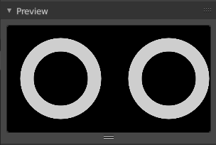
Image type Image or Movie.
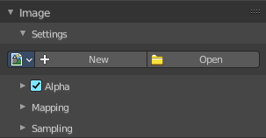

Image Property
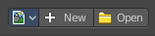
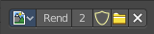
Load an image and / or switch to other images.
From left to right ...

Image Browser
This is a list of the images in the scene. This list allows you to switch to other images.

New / Open
When nothing is loaded then you will see the New / Open buttons to load a new image, or to create a new one.

Image Edit Box
Read the name of the currently selected image. And you can rename the image here too.

Fake User
Wit this button you assign a fake user to this selected image.
Data, like images, that is not longer linked to anything else gets removed when you save and reload a scene. Bforartists has the concept of fake users to go around this behavior. An image with a fake user is in fact linked to something. And so it is not lost when you save and reload the scene.

Open Image
Load an image

Remove
Delete the image.

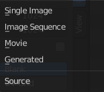
Source
Choose the image type. This type gets usually automatically set. When you create a new image, then this image is generated. When you load an image then the Source switches to Single Image.
Generated images does not have a path.

Source Type Generated

X / Y
The image width and height.

Float Buffer
Use a floating point buffer. 8 Bit images uses integers. 32 Bit works with floats.


Generated Type Blank
This type displays an image with one blank color

Color
The color of the blank image.


Generated Type UV Grid
This type displays a with a black and white checker texture but colored dots.


Generated Type Color Grid
This type displays a with a colored checker texture with numbers.


Color Space
Choose the color space type for the image.

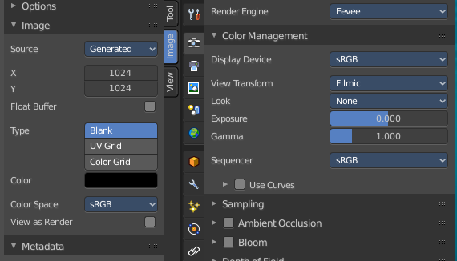
View as Render
Displays the image with the color management settings.

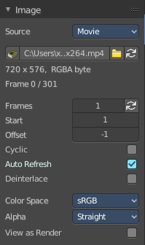
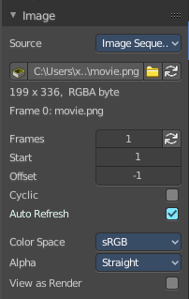
Source Type Movie + Image Sequence


Path edit box

Pack
With this button you can pack the movie or the image sequence into the blend file. It gets packed when you
save the blend file the next time.

Path edit box
See and edit the path to your movie or image sequence files.

Open
Open a new movie or image sequence files. A file dialog will appear.

Refresh
Reread the movie or image sequence files.

Info string
Some information about the currently loaded movie. Frames, resolution and color space.

Frames
The number of frames of the movie or image sequence.

Match Movie Length
Set Users Image Length to the one of this video.

Start
The start frame of the movie or image sequence

Offset
Offset the number of the frame to use in the animation. -1 means off.

Cyclic
Cycle the images in the movie.

Auto Refresh
Always refresh image on frame changes.

Deinterlace
Deinterlace the movie file on load.


Color Space
Choose the color space type for the movie or image sequence files.

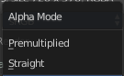
Alpha
Choose the alpha channel mode. Straight or Premultiplied.

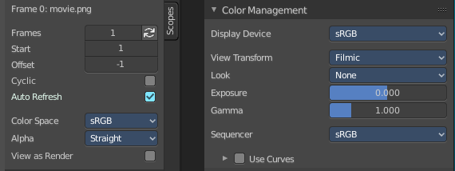
View as Render
Display the image with using the color management settings.

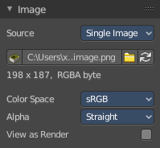
Source Type Single Image

Path edit box

Pack
With this button you can pack the movie or the image sequence into the blend file. It gets packed when you save the blend file the next time.

Path edit box
See and edit the path to your movie or image sequence files.

Open
Open a new movie or image sequence files. A file dialog will appear.

Refresh
Reread the movie or image sequence files.

Info string
Some information about the currently loaded image. Resolution and color space.


Color Space
Choose the color space type for the movie or image sequence files.

Alpha
Choose the alpha channel mode. Straight or Premultiplied.

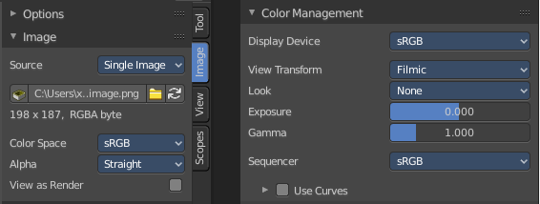
View as Render
Display the image with using the color management settings.

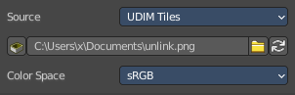
Source Type Udim
UDIM is an enhancement to the UV mapping and texturing workflow. And does not belong here. But in the UV Editor. It is just in the list because it shares the same menus with the UV Editor.

Image panel - Alpha Subpanel
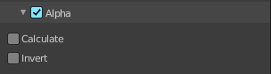
Use the Alpha channel that is stored in the image.

Calculate
Calculate an alpha based on the RGB values of the Image. Black (0, 0, 0) is transparent, white (1, 1, 1) opaque.

Enable this option if the image texture is a mask. Note that mask images can use shades of gray that result in semi-transparency, like ghosts, flames, and smoke/fog.

Invert
Reverses the alpha value. Use this option if the mask image has white where you want it transparent and vice versa.

Image panel - Mapping Subpanel

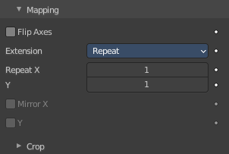
Control how the image is mapped or projected onto the 3D model.

Flip Axes
Rotates the image 90 degrees counterclockwise when rendered.

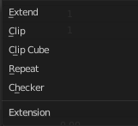
Extension

Extend
Outside the image the colors of the edges are extended.

Clip
Clip to image size and set exterior pixels as transparent. Outside the image, an alpha value of 0.0 is returned. This allows you to ‘paste’ a small logo on a large object.

Clip Cube
Clips to cubic-shaped area around the images and sets exterior pixels as transparent. The same as Clip, but now the ‘Z’ coordinate is calculated as well. An alpha value of 0.0 is returned outside a cube-shaped area around the image.

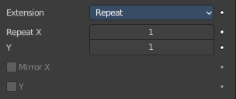
Repeat
The image is repeated horizontally and vertically.

Repeat X / Y
X/Y repetition multiplier.

Mirror X / Y
Mirror on X/Y axes. These buttons allow you to map the texture as a mirror, or automatic flip of the image, in the corresponding X and/or Y direction. They become active when the Repeat value is higher than 1.

Checker
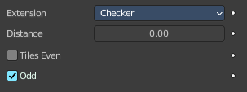
Checkerboards quickly made. You can use the option size on the Mapping panel as well to create the desired number of checkers.

Distance
Governs the distance between the checkers in parts of the texture size.

Tiles Even / Odd
Set even/odd tiles.

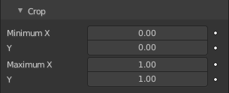
Crop Sub tab

Crop Minimum X / Y + Crop Maximum X / Y
The offset and the size of the texture in relation to the texture space. Pixels outside this space are ignored. Use these to crop, or choose a portion of a larger image to use as the texture.

Image panel - Sampling Subpanel

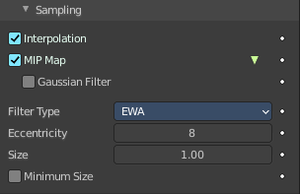

Interpolation
Interpolate pixels using selected filter type.

MIP Map
Use auto generated MIP maps.

Gaussian Filter
Use Gauss filter to sample down the mip map images.

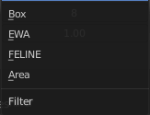
Fiter Type
The texture filter to use for sampling images.

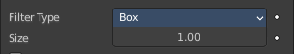
Type Box

Size
Multiply the filter size used by MIP map and interpolation.

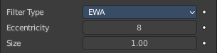
Type EWA

Eccentricity
Maximum eccentricity. Higher values gives less blur at distance angles and is slower.

Size
Multiply the filter size used by MIP map and interpolation.

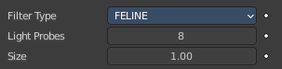
Type FELINE

Light Probes
Maximum number of samples. Higher values gives less blur at distance angles and is slower.

Size
Multiply the filter size used by MIP map and interpolation.

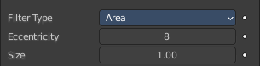
Type Area

Eccentricity
Maximum eccentricity. Higher values gives less blur at distance angles and is slower.

Size
Multiply the filter size used by MIP map and interpolation.

Minimum Size
Use the filter size as a minimal filter value.

Magic panel

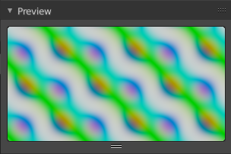
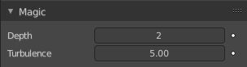
Image type Magic.

Depth
The depth of the calculation. A higher number results in a long calculation time, but also in finer details.

Turbulence
The strength of the pattern.

Marble panel

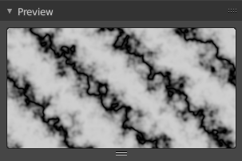
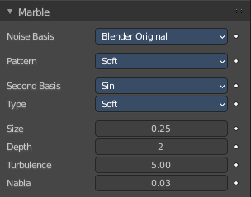
Image type Marble.

Noise Basis
What noise method to use.

Pattern
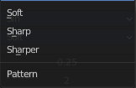
Settings for soft to more clearly defined Marble.

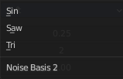
Second basis
Shape of wave to produce bands.

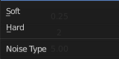
Type
The noise function works with two methods. Soft or hard.

Size
The dimensions of the noise table.

Depth
The depth of the Marble calculation. A higher value results in greater calculation time, but also in finer details.

Turbulence
The turbulence of the sine bands.

Nabla
Size of derivate offset used for calculating normal.
In order to calculate a normal, you usually use three samples in texture space. Typically that's the current sample location, and two other positions in texture U and V directions. This "nabla" value defines how far away these positions are.

Musgrave panel

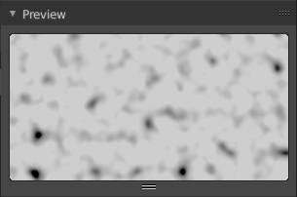
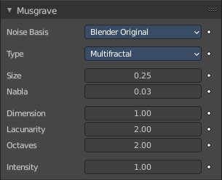
Image type Musgrave.

Noise Basis
What noise method to use.

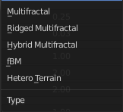
Type
What noise type to use.

Size
The input noise scale.

Nabla
Size of derivate offset used for calculating normal.
In order to calculate a normal, you usually use three samples in texture space. Typically that's the current sample location, and two other positions in texture U and V directions. This "nabla" value defines how far away these positions are.

Dimension
Fractal dimension controls the contrast of a layer relative to the previous layer in the texture. The higher the fractal dimension, the higher the contrast between each layer, and thus the more detail shows in the texture.

Lacunarity
Lacunarity controls the scaling of each layer of the Musgrave texture, meaning that each additional layer will have a scale that is the inverse of the value which shows on the button. i.e. Lacunarity = 2 –> Scale = 1/2 original.

Octaves
Octave controls the number of times the original noise pattern is overlayed on itself and scaled/contrasted with the fractal dimension and lacunarity settings.

Intensity
Light intensity. Called Offset for Hetero Terrain.

Offset
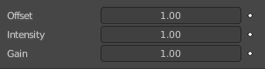
Hybrid Multifractal and Ridged Multifractal type. Both have a “Fractal Offset” button that serves as a “sea level” adjustment and indicates the base height of the resulting bump map. Bump values below this threshold will be returned as zero.

Gain
Hybrid Multifractal and Ridged Multifractal type. Setting which determines the range of values created by the function. The higher the number, the greater the range. This is a fast way to bring out additional details in a texture where extremes are normally clipped off.

Stucci panel

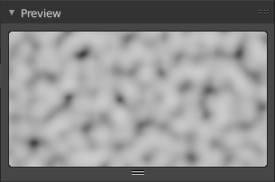
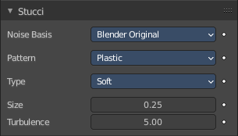
Image type Stucci.

Noise Basis
What noise method to use.

Pattern
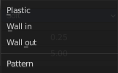
Plastic is the standard Stucci, while the “walls” is where Stucci gets it name. This is a typical wall structure with holes or bumps.

Type
There are two methods available for working with Noise. Soft or Hard.

Size
Dimension of the Noise table.

Turbulence
Depth of the Stucci calculations.

Voronoi panel

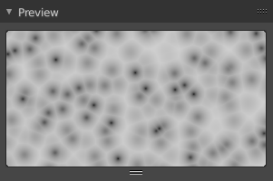
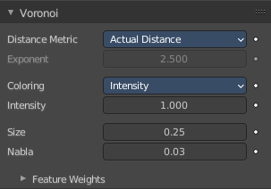
Image type Voronoi.

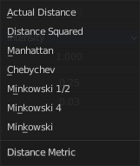
Distance Metric
This procedural texture has seven Distance Metric options. These determine the algorithm to find the distance between cells of the texture.

Exponent
The Minkowski setting has a user definable value (the Exponent button) which determines the Minkowski exponent e of the distance function.

(xe + ye + ze)1/e

A value of one produces the Manhattan distance metric, a value less than one produces stars (at 0.5, it gives a Minkowski 1/2), and higher values produce square cells (at 4.0, it gives a Minkowski 4, at 10.0, a Chebychev). So nearly all Distance Settings are basically the same – a variation of Minkowski.

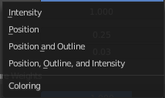
Coloring
Different ways to calculate color and intensity of the texture output.

Feature Weights subpanel
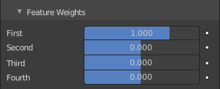
These four sliders at the bottom of the Voronoi panel represent the values of the four Worley constants, which are used to calculate the distances between each cell in the texture based on the distance metric.

Wood panel

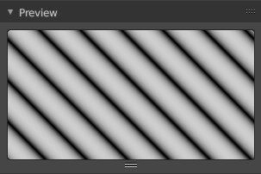
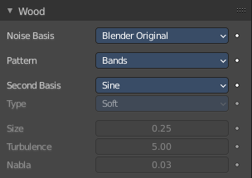
Image type Wood.

Noise Basis
What noise method to use.

Pattern
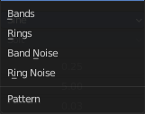
The wood pattern.

Type, Size Turbulence and Nabla are just active with Pattern Type Band Noise and Ring Noise.

Second basis
Shape of wave to produce bands.

Type
Smooth transitions or sharp transitions. Changes contrast and sharpness.

Turbulence
The turbulence of band noise and ring noise.

Nabla
Size of derivate offset used for calculating normal.
In order to calculate a normal, you usually use three samples in texture space. Typically that's the current sample location, and two other positions in texture U and V directions. This "nabla" value defines how far away these positions are.

Colors Panel
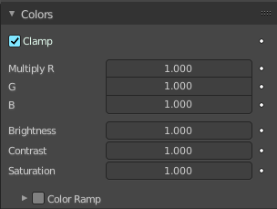

Clamp
Clamps the range by setting the negative rgb and intensity values to zero.

Multiply R G B
Multiply factor for the r g and b channel.

Brightness
The brightness of the texture.

Contrast
The contrast of the texture.

Saturation
The saturation of the texture.

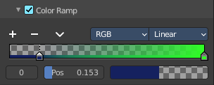
Color ramp subpanel
Specify a range of colors based on color stops. The color between the color stops gets interpolated.

+
Add a stop to your color ramp. The stop will be added after the selected one, in the middle to the next one.

-
Deletes the selected color stop from the list.


Tools menu

Flip Color Ramp
Flips the gradient, inverting the values of the color ramp.

Distribute Stops from Left
Rearrange the stops so that every step has the same space to the right.

Distribute Stops Evenly
Space between all neighboring stops becomes equal.

Eyedropper (pipette icon) E
An Eyedropper to sample a color or gradient from the interface to be used in the color ramp.

Reset Color Ramp
Resets the color ramp to its default state.


Color Mode

RGB
Blends color by mixing each color channel and combining.

HSV/HSL
Blends colors by first converting to HSV or HSL, mixing, then combining again. This has the advantage of maintaining saturation between different hues, where RGB would de-saturate, this allows for a richer gradient.


Interpolation

Ease
Uses an Ease Interpolation for the color stops.

Cardinal
Uses a Cardinal Interpolation for the color stops.

Linear
Uses a Linear Interpolation for the color stops.

B-Spline
Uses a B-Spline Interpolation for the color stops.

Constant
Uses a Constant Interpolation for the color stops.

Color Ramp
The color band. A click at one of the color stops makes it the active one. You can move the color stops by clicking at them and dragging them around.

Active Color Stop elements
Adjust the active color stop.

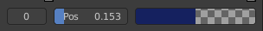
Choose active color stop
Choose the color stop by index.

Pos
The position of the active color stop. The range goes from 0.000 to 1.000

Color
The color of the active color stop. Clicking at it opens a color picker.

Custom Properties Panel


Here you can define custom properties that can be used for scripting.

Here you might also find custom properties from addons or scripts.

Add
Adds a new property.


Edit
Opens a panel where you can adjust the settings for the custom property.

Remove
Removes the property.

